

Imaging Neuronal Populations in Freely Moving Animals

Dr. Vania Cao

Application Scientist, Application Science and Support team, Inscopix

2014年9月24号 16:00PM
703楼五楼报告厅

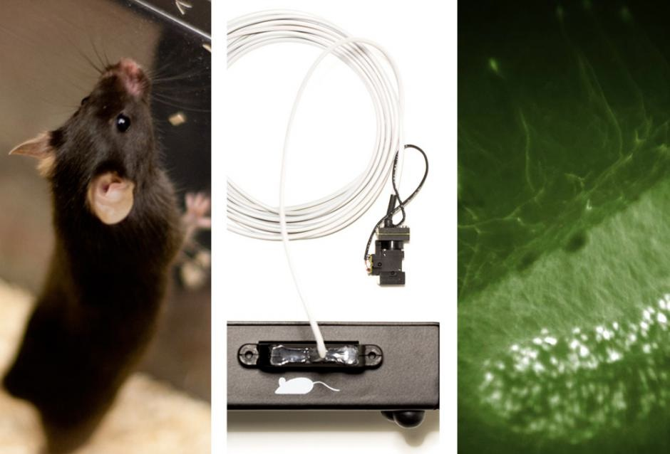
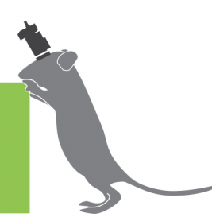
nVista HD is the first end-to-end solution for visualizing large-scale neural circuit dynamics in freely behaving animals. With nVista HD, neuroscientists can ask entirely new questions about how neural circuits shape behavior.

