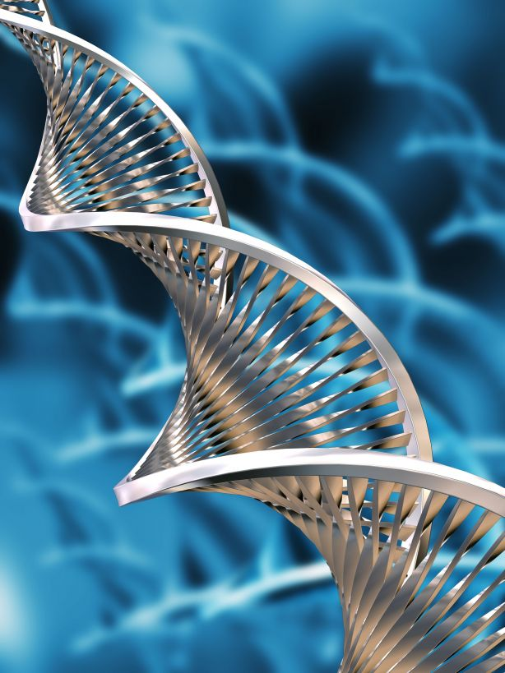
学术报告 
Title：Genetics of Episodic Neurological Diseases
Seminar Speaker：Louis J. Ptáček, MD
Professor, Department of Neurology School of Medicine, University of California San Francisco
Investigator, Howard Hughes Medical Institute
John C. Coleman Distinguished Professorship in Neurodegenerative Diseases
Dr. Ptáček was recruited to UCSF to lead a Division of Neurogenetics within the Department of Neurology. Dr. Ptáček is a leader in the field of human neurogenetics. His group began work years ago to characterize a large group of episodic disorders that have come to be known as the “channelopathies” because many result from mutations in a variety of voltage- and ligand-gated ion channels. More recently, he and Chris Jones described a Mendelian variant of circadian behavior in humans called familial advanced sleep-phase syndrome (FASPS). His productive collaboration with Dr. Ying-Hui Fu over the last decade has resulted in the identification and characterization of numerous genes causing muscle disease, epilepsy, movement disorders and FASPS. Their work has always begun by studying families with neurological phenotypes but has translated into biological characterization of the encoded proteins and modeling of genetic variants in other organisms.

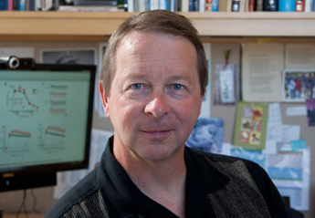

Recent Publication:
- Lin S-T, Huang Y, Zhang L, Heng M, Ptáček LJ and Fu Y-H. miR-23a promotes myelination in the central nervous system. Proc Natl Acad Sci USA. 2013 Oct 22;110(43):17468-73.
- Ryan DP, Dias da Silva MR, Soong TW, Fontaine B, Donaldson MR, Kung AWC, Liang MC, Khoo DHC, Cheah JS, Ho SC, Bernstein HS, Maciel RMB, Brown RH, Ptáček LJ. Mutations in Potassium Channel Kir2.6 Cause Susceptibility to Thyrotoxic Hypokalemic Periodic Paralysis. Cell. 2010 140(1): 88-98.
- Xu Y, Toh KL, Jones CR, Shin JY, Fu Y-H*, Ptáček LJ. Modeling of a human circadian mutation yields insights into clock regulation by PER2. Cell. 2007 Jan 12;128(1):59-70.
报告时间：2014年9月26日 2:30 PM
报告地点：703楼五楼报告厅

