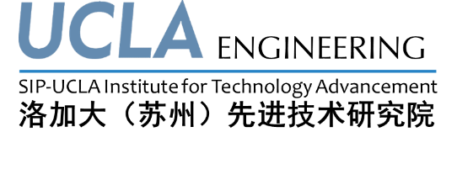



Invitation
邀请函

2014 Dushu Lake International Forum on Environment and Health
Suzhou, Jiangsu, China
Tuesday & Wednesday, Nov 4th and 5th, 2014

2014独墅湖国际环保与健康高峰论坛
中国·江苏·苏州
2014年11月04日-05日


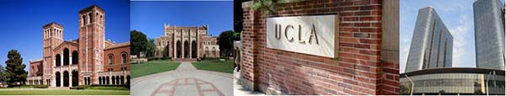
JinlingGuanyuan International Hotel Suzhou | 苏州金陵观园国际酒店
NO.168 Cuiwei Street, Suzhou Industrial Park | 苏州工业园区翠薇街168号
Language: English and Chinese | 语言：英文和中文

In 2012 a Master Affiliation Agreement (MAA) was signed between Suzhou Industrial Park (SIP) and the University of California, Los Angeles to promote strategic collaboration between the two entities. As a result of the MAA, in March 2013 the SIP-UCLA Institute for Technology Advancement (SIP-UCLA ITA) was established between SIP and the Institute for Technology Advancement of the UCLA Henry Samuelli School of Engineering and Applied Science. The mission of the newly established joint institute is to promote collaboration in the areas of academic exchanges, student programs, talent cultivation, and to facilitate entrepreneurship and innovations from both SIP and UCLA.
美国加州大学洛杉矶分校（UCLA）与苏州工业园区于2012年11月建立战略合作关系，并共同签定了合作“主框架协议”。2013年3月，苏州工业园区与洛加大工程及应用科技学院先进技术研究院在苏州独墅湖科教创新区正式筹建“洛加大（苏州）先进技术研究院”。本研究院的主要宗旨是加强苏州及UCLA在学术交流、学生教育、高端技术与创新研发人才的培养、技术研发和产业孵化、以促进苏州工业园区和UCLA的创新技术和创业团队的成长。
The Board of Directors of the Institute cordially invites you to attend the opening ceremony of SIP-UCLA ITA on November 4-5, 2014, together with 2014 Dushu Lake International Forum on Environment and Health, at the Jinling Guanyuan International Hotel in Suzhou. The ceremony will be followed by Keynote Speeches by two internationally renowned scholars from UCLA. The keynote speeches will also mark the opening of the “2014 Dushu Lake International Forum on Environment and Health” held on Nov. 4-5th at the same venue. This forum will invite academicians from U.S. National Academy of Engineering and experts of UCLA, scholars and professors from famous Universities of China, experts entitled with the Thousand Talent and many Institutes and communities for Environmental Protection to address environment issues on water, soil, air and relevant technologies. A list of experts and speakers can be found in the attachment.
洛加大（苏州）先进技术研究院理事会诚挚邀请您于2014年11月4日-5日参加研究院的开幕仪式暨2014年独墅湖国际环保和健康论坛会议，仪式和会议将在苏州金陵观园国际酒店隆重举行。开幕式后将由二位国际知名专家于上午10点至12点作有关水资源和环境保护领域的主题演讲，主题演讲同时也代表了由本研究院主办的11月4日-5日的为期2天的“2014独墅湖国际环保与健康高峰论坛”正式开始。本次会议将使中美各院校和环保研究机构、政府环保决策机构、以及各环保科技企业共聚一堂，会议将涵盖大气、水、土壤及环保应用技术等四个方向。专家和发言人的名单在附件里可以找到。

We would be honored to have you attend our opening ceremony.
我们很高兴地邀请您参加研究院的开幕仪式和国际环保会议，您的参与将是我们的荣幸。

（Conference agenda can be found in the attachment 1. 会议议程请参考附件1。）

Sincerely yours（诚挚的）
SIP-UCLA Institute for Technology Advancement（洛加大（苏州）先进技术研究院）

Chairman of the Conference（大会主席）：
Dr. Dwight Streit, member of U.S. National Academy of Engineering, Dean of the UCLA Institute for Technology Advancement, Director and Professor of Department of Material, Director of the UCLA (Suzhou) Institute for Technology Advancement（白尚礼博士，美国国家工程学院院士，UCLA先进技术研究院院长，UCLA材料系系主任及教授，洛加大（苏州）先进技术研究院院长）
Co-Chairman of the Conference（大会共同主席）：
Dr. J.M.Yang（杨镇铭博士），Dr. W.H.Kao（高为雄博士）
Executive Chairman of the Conference（大会执行主席）：
Dr. W.S.Zhou（周文生博士）

附：
独墅湖国际环保与健康高峰论坛会议演讲嘉宾名单
2014 Dushu Lake International Forum on Environment and Health Speaker List
No. | 姓名 Name | 职务 Position | 所在单位 Working Unit | 演讲题目 Lecture Title
01 | 叶文工  William W-G. Yeh | 美国工程院院士  Member of NAE | 美国加州大学洛杉矶分校  UCLA, U.S. | 美国南加州的地表水和地下水联合利用规划  Conjunctive Use Planning of Surface Water and Groundwater in Southern California, USA
02 | 白尚礼  Dwight C.Streit | 美国工程院院士  Member of NAE | 美国加州大学洛杉矶分校  UCLA, U.S.
03 | 颜利平  Liping Yan | 博士，项目经理，技术总监  Dr., PM, CTO | 美国洛杉矶市水电局能源系统岩土工程处  Energy System and Geotechnical Engineering Department of L.A. Electricity and Water Authority, U.S.  美国西南岩土工程公司  American Southwest Geotechnical Engineering Co. | 饮用水的供应–美国洛杉矶市的经验给我们的启示  The experience of supply of drinking water in Los angels in America
04 | 崔振东  Zhendong Cui | 博士，岩土工程研究所副所长、教授  Dr., Professor and Deputy Director | 中国矿业大学力学与建筑工程学院  Geotechnical Institute of Department of Mechanics and Construction Engineering, China University of Mining | 软土地区密集高层建筑群引起地面沉降研究  The study of land subsidence caused by intensive high-rise buildings in soft soil area
05 | 程裕富  Yufu Cheng | 博士，中国区总裁  Dr., President | 国际区域气候行动组织  International Organization for Regional Climate Action | 低碳行动与生态环保  Low carbon and ecological environmental protection
06 | 霍毅欣  Yixin Huo | 博士  Dr. | 美国加州大学洛杉矶分校  UCLA, U.S. | 电燃料和蛋白质生物精炼：生产基础化学品和生物燃料的新策略  Electrofuels and Protein-based biorefining: Novel strategies to produce bulk chemicals and fuels
07 | 沈若朴  Claire Shen | 教授  Professor | 国立清华大学化学工程系  Chemical Engineering Department of Taiwan National Tsing Hua University | 代谢工程应用于再生能源与材料  Metabolic Engineering for the production of renewable fuel and chemical
08 | 王一明  Yiming Wang | 研究员，教授  Researcher, Professor | 中国科学院南京土壤研究所  Soil Institute at Nanjing ,Chinese Academy of Sciences | 中国固体有机废物的资源化  Resource Chinese solid organic waste
09 | 康鹏  Peng Kang | 博士  Dr. | 北卡罗来纳州大学教堂山分校  University of North Carolina at Chapel Hill, U.S. | 利用分子催化剂将CO2电催化还原为甲酸盐和合成气  Electrocatalytic Reduction of CO2 to Formate and Syngas Using Molecular Catalysts
10 | 徐渊平  Yuanping Xu | 博士  Dr. | 达晨创投  Fortune Venture Capital , China | 资本市场眼光看生物能源  Capital market perspective of bio energy
11 | Ken C. Lai | 中国区域副总裁中国区域副总裁  Vice President in China | Lanzatech.公司  Lanzatech. Co. | 废燃料和化学品  Waste To Fuel & Chemicals
12 | 蒋宇  Yu Jiang | 教授  Professor | 中国科学院合成生物学重点实验室  State Key Laboratory for Synthetic Biology of Chinese Academy of Sciences | 正丁醇生产现状及在中国的前景  Current status and prospects of industrial bio production of n-butanol in China
13 | 童卫星  Weixing Tong | 博士,高级工程地质师  Dr. Senior Engineering Geologist | 美国加利福尼亚州环保署洛杉矶水质管理局  L.A. Water Quality Authority of California Environmental Protection Agency(EPA), U.S. | 地下储油罐污染场地的政府管理-美国经验  Governmental management of contaminated sites for underground oil tank-American experience
14 | 容跃  Yue Rong | 博士，环境项目经理  Dr., Environmental Program Manager | 加利福尼亚地区水质控制委员会  California Regional Water Quality Control Board | 美国加州地下水污染在位修复及政府行政管理方法  situ groundwater remediation and regulatory management method in California, USA
15 | 仵彦卿  Yanqing Wu | 教授  Professor | 上海交通大学  Shanghai Jiao Tong University | 土壤与地下水污染修复技术应用中的若干问题  Problems of soil and groundwater remediation technology in the application
16 | Ravi Arulanantham | 博士  Dr. | Geosyntec Consultants | 健康风险评估在环境决策中的应用  Application of health risk assessment for environmental decision making
17 | 廖晓勇  Xiaoyong Liao | 博士  Dr. | 中科院地理所  Institute of Geographic Science and Natural Resources Research, CAS | 场地污染修复决策支持系统的关键科学问题思考  Thinking of key scientific problems of site contamination repair decision support system
18 | 张幼宽  Youkuan Zhang | 院长，特聘教授  Dean, Distinguished Professor | 南京大学水资源学院院长，中组部“千人计划”特聘教授  The College of water resources of Nanjing University, “1000 talent” of Organization Department of the CPC Central Committee
19 | 马俊  Jun Ma | 博士，技术总监，北京市特聘专家  Dr., Technical Director, Distinguished experts of Beijing | 北京建工环境修复有限公司  BCEG Environmental Remediation CO., LTD.
20 | 李喜青  Xiqing Li | 教授  Professor | 北京大学城市与环境学院  Beijing University Urban and Environment College | 泡沫是一种很有前途的传输包气带修复的纳米粒子的介质  Foam, a promising vehicle to deliver nanoparticles for vadose zone remediation
21 | 宋国君  Guojun Song | 教授，所长  Professor, Institute Director | 中国人民大学环境政策与规划研究院  Institute of Environmental Policy & Planning, School of Environment, Renmin University of China | 中国空气固定源排放状况报告  The Chinese report of stationary source emissions in the air
22 | Casandra Rauser | 博士，主任  Dr., Director | 美国加州大学洛杉矶分校研发副校长办公室  Environment and Sustainability, the UCLA Office of Vice Chancellor for Research | 洛杉矶环境大挑战计划  Environment Grand Challenge program in LA
23 | 龚宇阳  Yuyang Gong | 博士，董事总经理  Dr., Managing Director | 中环循（北京）环境技术中心  ESD China Limited | 退役场地建筑与设备风险评估与无害化治理  Risk assessment and harmless treatment of decommissioning site construction and equipment
24 | 何磊  Lei He | 教授  Professor | 美国加州大学洛杉矶分校  Electrical engineering department, UCLA | 物联网（IOT）的水和能量守恒  Internet-of-Things (IoT) for water and energy conservation
25 | 魏丽  Li Wei | 总经理  General Manager | 北京高能时代环境修复有限公司  Beijing GeoEnviron Engineering & Technology .lnc | 中国污染场地修复行业现状及发展趋势  Current situation and development trend of Chinese contaminated site remediation industry
26 | 卢晓霞  Xiaoxia Lu | 教授  Professor | 北京大学  Peking University | 通过填充有机覆盖物的渗透反应去除地下水中的铬的专题研究  Column study on removal of Chromium (IV) from groundwater by permeable reactive barrier filled with organic mulch
27 | 张建荣  Jianrong Zhang | 副所长，研究员级高级工程师  Associate Director | 苏州市环境科学研究所  Institute of Environmental Science, Suzhou | 场地污染土壤治理进程及典型案例  The governance process and typical cases of site soil pollution
28 | 张仁泉  Renquan Zhang | 副主任，研究员级高级工程师  Associate Director | 苏州市环境监测中心  Environmental Monitoring Center, Suzhou | 苏州市环境质量状况  Environmental quality status of Suzhou
29 | 范国平  Guoping Fan | 教授  Professor | 美国加州大学洛杉矶分校医学院人类遗传学系  Department of Human Genetics, David Geffen School of Medicine, UCLA | 运用基因组学新技术研究环境和健康科学  Genome Technologies in Environmental Health Sciences
30 | Michael Jerrett | 教授  Professor | 加州大学伯克利分校 公共环境卫生系系主任；加州大学洛杉矶分校环境卫生系候任系主任  UC Berkeley, Division of Environmental Health Sciences  Affiliate, UCLA, Department of Environmental Health | 环境监测科学的最新进展  Advances in Environmental Monitoring: Exposome with Participatory and Ubiquitous Sensing
31 | 金陶胜  Taosheng Jin | 副教授  Associate Professor | 南开大学环境科学与工程学院  College of Environmental Science and Engineering, Nankai University | 移动源排放污染对大气环境与人体健康的影响  The Influence of Mobile Source Emission on Atmospheric Environment and Human Health

附：
参会回执
Company Name
单位名称
Attendee  参会者姓名 | Title  职位 | Tel  电话 |  | Email  电子邮箱
参会时间段（请在相应的参会时间段划勾）
Time Quantum(Please check out the time when you can participate the sessions)
11月4日上午  Nov. 4th | 11月4日上午  Nov. 4th |  | 11月5日上午  Nov. 5th |  | 11月5日下午  Nov. 5th
□ | □ |  | □ |  | □
就餐安排  Dinner Schedule | 请填写就餐人数 Please check up the dinner：  4日中餐 （） 5日中餐（）  4th Lunch（） 5th lunch（）
备注：
Please email the Registration Form to szucla@163.com by Oct. 31, 2014
请将参会回执填好后在2014年10月31日前发送至szucla@163.com

If you have any question, please contact: Mr. Jason Xue
如果您有任何问题，请联系：薛军锋先生
+86-0512-87663611-8022, +86-18862249650, szucla@163.com

附：
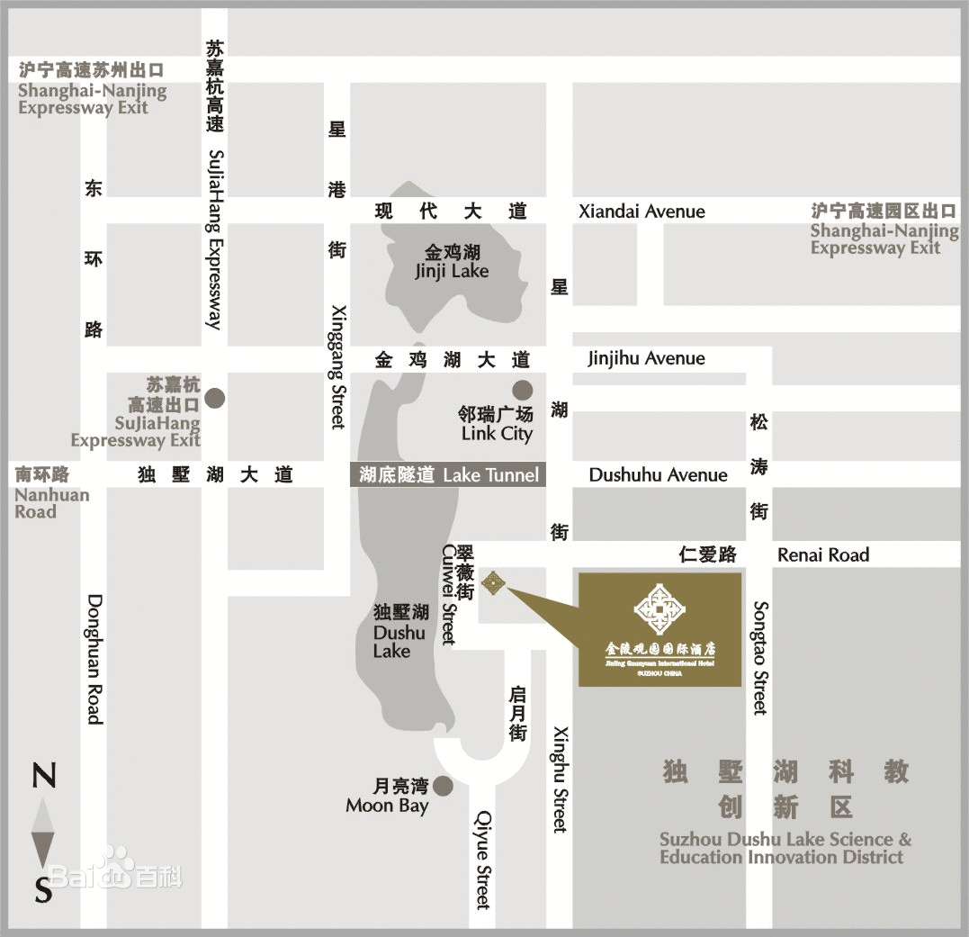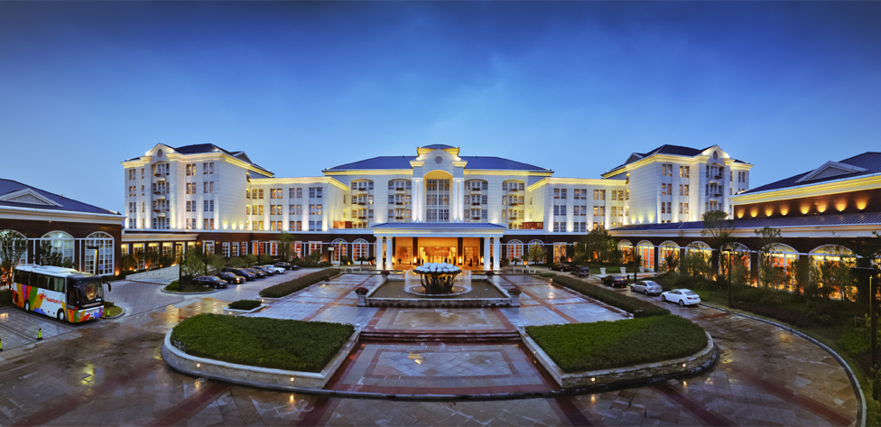Venue 会议地点交通示意图

举办单位：洛加大（苏州）先进技术研究院
单位地址：中国江苏省苏州市工业园区月亮湾路10号慧湖大厦A座12楼1201室
Phone/电话：+86-0512-87663611 Fax/传真：+86-(0)512-86868025
E-Mail/邮箱：info@szucla.org Website/网站：www.szucla.org

